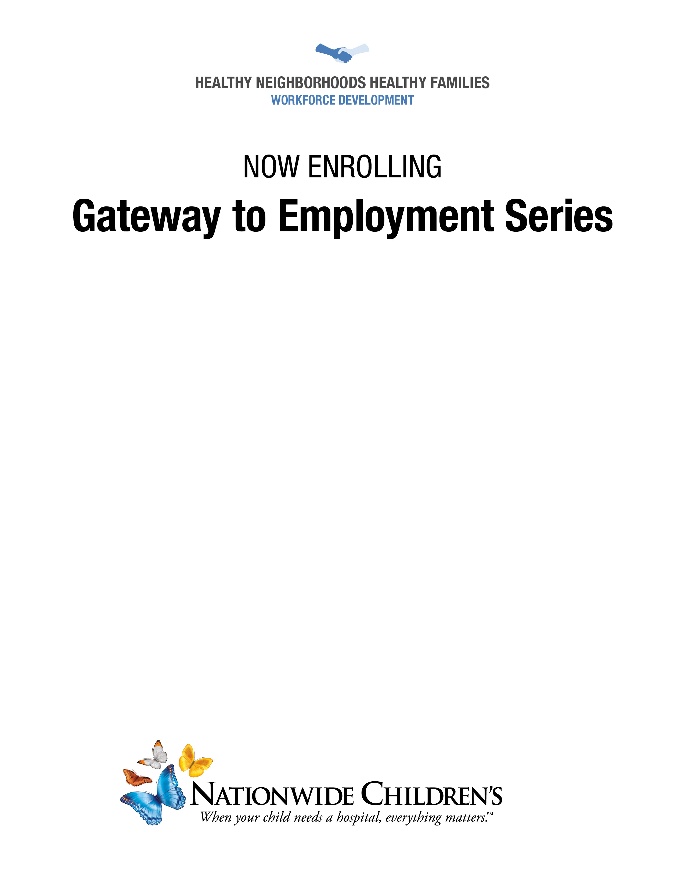

Join by Phone: 1-415-655-0001 Conference ID: 619 836 706

Join by WebEx: <https://bit.ly/2zDfXI5>

**Learn more by searching “Behavioral Health Webinar Series” at NationwideChildrens.org**

**Sleep Strategies: Behavioral Strategies to Improve Sleep in Patients Ages Six Months Through Adulthood**

**Presented by: Jack Stevens, PhD**



**June 17, 2020 | 12:00 to 1:00 p.m.**

*This session is eligible for 1.0 Category 1 CE credit upon completion of the CE Evaluation Survey.*

**Behavioral Health Webinar Series for Primary Care**