Sample Communication Messages for Anthem Changes
Please feel free to copy and paste to use these for your practice.

SCRIPTING TO USE FOR PATIENT FAMILES WHO HAVE ANTHEM MEDICAID
“I see your health insurance coverage is through Anthem’s Medicaid plan. For now, NAME OF OUR PRACTICE is out-of-network with Anthem Medicaid. You can find a provider who accepts Anthem Blue Cross and Blue Shield, call Member Services 844-912-0938 (TTY 711) Monday through Friday from 7 a.m. to 8 p.m. But to avoid future problems, you may want to consider switching to another Medicaid plan – we are in network with all of them except Anthem. You can do that by visiting OhioMH.com, or by calling Ohio’s Department of Medicaid at 800-324-8680.”

COPY FOR A HANDOUT OR EMAIL
News For Families Covered by the new Anthem Medicaid Plan
Starting February 1, 2023, Ohio’s new Medicaid health insurance plans go into effect for families. Read on to see how you might be affected by this change.
What is the change?
Ohio Medicaid has seven different plans. That means there are seven different organizations that handle your Medicaid health benefits. You will either be assigned to a plan, or you can choose the plan you want. Six plans cover health care of your child at name of practice. One, Anthem Blue Cross and Blue Shield, does not.
What are the plans that cover our services?
There are six plans that cover our services. They include:
- AmeriHealth Caritas Ohio
- Buckeye Health Plan
- CareSource Ohio
- Humana Healthy Horizons
- Molina HealthCare of Ohio
- UnitedHealthcare Community Plan of Ohio

If you want to make sure your services are not interrupted at our practice, you can change your plan from Anthem Blue Cross and Blue Shield to one of the plans above that covers our services:
How do I know which plan I am on?
If your family has Medicaid, please check your card to see which plan you have. If you are new to Medicaid, your card might not have that information.
Do all the plans cover services at NAME OF YOUR PRACTICE?
No. If you are assigned to Anthem Blue Cross and Blue Shield’s Medicaid plan, you are not covered for health services at NAME OF YOUR PRACTICE as of February 1, 2023.

If I am assigned to Anthem Blue Cross and Blue Shield’s Medicaid plan, what can I do?
You can find a provider who accepts Anthem Blue Cross and Blue Shield, call Member Services 844-912-0938 (TTY 711) Monday through Friday from 7 a.m. to 8 p.m. You also have the option to choose a different plan. You must make this switch before May 1, 2023.
How do I change plans?
- Visit OhioMH.com or scan the QR code and click “Select a Plan Online” under “I Would Like to Select My Plan.”
- Call 800-324-8680.

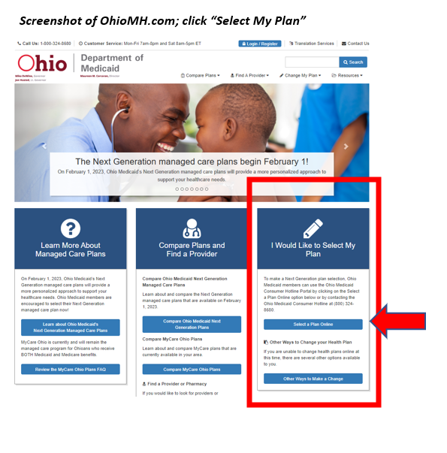
You will be asked to provide:
Member name
Case number (can be found on letters you have received from the Department of Job and Family Services re: your Medicaid eligibility)
Member billing number (12 digit number can be found on your Medicaid card and may also be referred to as the Member ID number)
Member date of birth
Member’s social security number
Email address

